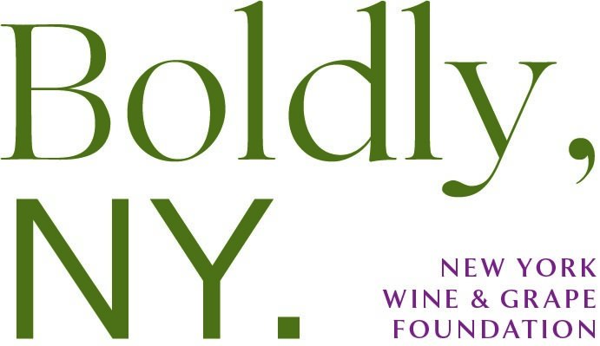

REQUEST FOR PROPOSAL FOR
RESEARCH PROJECTS
Funding is for NYWGF Fiscal Year
April 1, 2023– March 31, 2024

Proposals must be submitted by January 17, 2023

Dana Alexander
Director of Operations
New York Wine & Grape Foundation
1 Keuka Business Park, Suite 208
Penn Yan, NY 14527
315-924-3705
www.newyorkwines.org
research@nywgf.org

- Introduction

The New York Wine & Grape Foundation (NYWGF) was created by the State of New York in 1985 as a private, non-profit organization. The enabling legislation established a financing mechanism for promotion and research, providing the industry with both short-term assistance and the potential for long-term viability. NYWGF’s programs are developed by a 20-member Board of Directors in consultation with other representatives from industry and state government. The activities carried out by NYWGF are designed to support all uses of New York grown grapes from all regions of the state.

Every year, a significant portion of our budget is allocated to our Research program to fund projects that support the overall improvement in production and quality of wine, grapes, and grape products for the New York wine industry. The NYWGF Board Research committee reviews the project proposals and presents a recommended research budget to the full board for consideration as part of the budget process.

- Proposal submittal process and expectations:

  - Deadline: Proposals must be submitted electronically by January 17th, 2023, using our NYWGF Proposal template and emailing to research@nywgf.org.

  - Scoring: Projects will be scored based on the following criteria:
- Does the project align with one or more industry priorities?
- Does the project look to produce an important impact on the industry, either regionally or statewide?
- Is the proposed research justified, either as a continuing or new project?
- Does the budget seem in line with the size and scope of the research being suggested?
- Feasibility of proposed workplan and proposal presentation.

  - Funding:
- Private sector funding is welcomed with each proposal, but not required.
- If funding is also being sought or has been received from other sources to support the proposed project, a letter identifying the funder and stating the dollars requested or awarded must be submitted with this proposal.
- Invoices will be submitted to NYWGF on a reimbursement basis.
- For all funded projects, NYWGF should be acknowledged as a funder on all online and printed materials and presentations.

  - Final Report: A final report must be submitted electronically by March 30th using our NYWGF Final Report template to research@nywgf.org.

  - Reporting session: All researchers will be asked to present their results from their currently funded projects, and answer questions on newly submitted proposals to the members of NYWGF Research Committee on February 9, 2023 at Cornell AgriTech in Geneva NY and for those who cannot join us in person, via Zoom video conference using the following link: https://nywgf.zoom.us/j/7591657459.

- Project Priorities

Every year, research priorities are discussed and finalized by the Research Committee of the Board of the NYWGF in collaboration with additional stakeholder input, to help the researchers focus their research proposals to meet the current needs of the wine and grape industry.

The priority themes for this year are as follows:

VITICULTURE:

- Mechanization and precision agriculture: Identify opportunities for vineyard management mechanization and application of precision agriculture technology with a particular emphasis on development of labor saving and affordable canopy management equipment.

- Floor and weed management: Develop and evaluate vineyard floor and weed management strategies to reduce energy and herbicide use.

- Sustainability: Develop and evaluate vineyard management strategies to efficiently utilize nutrient inputs and promote long term soil health and water quality.

- Disease & Pest management, including Invasive species: Develop effective, efficient and sustainable disease and pest management materials and techniques that minimize development of resistance and provide resilience to climate change. Develop management approaches to combat impact of invasive species, including but not limited to spotted-wing drosophila and spotted lanternfly.

ENOLOGY:

- Wine quality: Develop and evaluate techniques and materials to improve quality of wine made from cold hardy hybrid and native grape varieties.

- Grape varieties and clones: Develop and evaluate new grape varieties and/or clones of current varieties that are suitable for making quality wine in New York’s diverse wine growing regions and that are resilient to climate change.

BUSINESS MANAGEMENT:

- Customer acceptance: Identify and test education and communication strategies to promote customer acceptance of wines made from cold hardy hybrid and native grape varieties.

- Customer awareness: Identify and test education and communication strategies to increase customer awareness of the diversity and quality of New York wines.

- Proposal Format:

At the bottom of this document is a link to our NYWGF proposal template for you to fill in with the details of your proposal. Below is an outline of the template with additional details.

SECTION 1: DETAILS

Project Title:
Principal Investigator:
(include name, position, univ affiliation and contact information-email/phone)
Co PI’s, Collaborators:
(include name, position, univ affiliation and contact information-email/phone)
New Research ☐ Continued Research ☐
(If continued funding under a different project, give former name)
Amount Requested $xxxxx (Funding is for April 1, 2023– March 31, 2024)

SECTION 2: SUMMARY

Please provide a brief summary (4-5 sentences) in layman’s terms describing the purpose of your project; what goal you are trying to achieve, and why.

SECTION 3

Express the focus of the research in clear, concise language and include:

Objectives: Describe how the research will address the industry priority.

Justification of Research: Describe previous work that has been done, how the proposed project is diversified from any current and/or prior projects and the importance of the proposed research to the industry. What will the impact be?

Materials & Methods: Outline your work plan including the experimental procedure & materials used.

Expected outcomes: State the various expected outcomes (economic, environmental etc.)

Communication of Results: Outline the plan to broadly communicate the research results to a producer audience, including the type of technology you plan to use (ie meetings, emails, newsletters).

SECTION 4: BUDGET

Budget: We anticipate funds will be available April 1, 2023 - March 31, 2024.
Please include in this section the details for the expenses listed below.

- Personnel Services: (include description and amount)
    - Salary and wages, include fringe benefits

- Non-Personnel Services: (include description and amount)
    - Contractual services. Travel. Equipment. operating expenses. other

Additional Funding: Please include in this section any information regarding additional private sector funds expected from outside sources. Please identify if these funds will run through NYWGF or go directly to your employer.

- Reporting Session PowerPoint Presentation: *This year we will be asking researchers to complete a PowerPoint point presentation of no more than 4 pages that includes what their project was, what they hoped to achieve, what happened, and what’s next.

- Final Report Format (to be completed by March 31, 2024)

SECTION 1

Project Title:
Principal Investigator:
Co PI’s, Collaborators:
(Note their affiliations and contacts, including phone numbers) *please attach bio
New Research ☐ Continued Research ☐
Amount Funded $xxxxx

SECTION 2
Final report should include the following sections:

- Summary Impact Statement: Provide 3-5 sentences summarizing the purpose of the project and its impact on the industry.
- Objectives
- Activities/Methods
- Results/Progress/Next steps
- Technology Transfer Plan including dates and descriptions of outreach activities and publications
- Attach any relevant charts, graphs and photos

SECTION 3
This section should be brief and written in terms understandable for the average grower and producer)

- Project objectives
- Importance of research to the NY wine industry
- Project Results/next steps
- Supporting attachments: (Choose a maximum of 1 supporting figure or table to demonstrate results if applicable)

Click Here for Final Report Template

- Contact information and deadline for submissions

Proposals must be submitted to NYWGF electronically by January 17th, 2023, using our NYWGF template (below) to research@nywgf.org.

Any questions can be directed to Dana Alexander at the New York Wine & Grape Foundation using danaalexander@nywgf.org, or by phone 315-924-3705.

Click Here for Proposal Template

